Data Model Specification
FOR
Volunteer Management System
(VMS)

CLIENT | Liu Peishan
PROJECT | Volunteer Management System (VMS)
TITLE | Data Model Specification
VERSION | 0.2
DATE | 30-Nov-2011
 | ORIGINATOR
 | Name / Signature | Team 8S
 | APPROVAL
 | Name / Signature | Phung Kim Cuong, Dio
Institute of Systems Science |  | Document Reference
25 Heng Mui Keng Terrence  Singapore 119615 |  | VMS/T-1.5.2/1

 | Acceptance
 | Customer Signature |  | Customer Signature
 | Name & Designation |  | Name & Designation
 | Date & Company Stamp |  | Date & Company Stamp

Revision History

Date | Version | Description | Author
20-Nov-2011 | 0.1 | Creation | Team 8S
30-Nov-2011 | 0.2 | Creation | Team 8S
 |  | Refer to amendment history

Table of Contents

1. High Level Application Architecture 3
1.1 Target Audience 3
2. Data Models 4
2.1 TB_USER 4
2.2 TB_USER_DETAIL 5
2.3 TB_CODE_CATEGORY 5
2.4 TB_CODE 6
2.5 TB_PROJECT 6
2.6 TB_PROJECT_PROPOSAL 7
2.7 TB_PROJECT_INTEREST 8
2.8 TB_PROJECT_MEMBER 9
2.9 TB_PROJECT_FEEDBACK 9
2.10 TB_PROJECT_EXPERIENCE 10
2.11 TB_PROJECT_TASK 11
2.12 TB_PROJECT_TASK_MEMBER 12
2.13 TB_DOCUMENT 12
2.14 TB_PROPOSAL_DOCUMENT 13
3. Entity Relationship Diagrams 13
ANNEX D Amendment History 15

High Level Application Architecture
The document describes the database design for the VMS . VMS system (hereby refer to as system) is used by the NGO staff and volunteers and is designed as a public web based application.

Target Audience
The Intended readers of this document are:
- the development team, to provide them with a high level database design of the system.

Data Models

TB_USER
This table contains the VMS user information.
No. | Column Name | Description | Key | Data Type | Length | Default | Nullable
 | USR_ID | User Id | PK | BigInt | 19 |  | N
 | USR_LOGIN_ID | User Login ID |  | Varchar | 20 |  | N
 | TP_CD | User Type Code - Refer to CAT_NME - "User Type" |  | BigInt
 | TITLE_CD | Title Code - Refer to CAT_NME - "Title" |  | BigInt | 19 |  | N
 | NME | Name |  | Varchar | 100 |  | N
 | EMAIL | Email |  | Varchar | 100 |  | N
 | PWD | Password |  | Varchar | 50 |  | N
 | MOBILE | Mobile |  | Varchar | 100 |  | Y
 | ADDR | Address |  | Varchar | 255 |  | Y
 | POST_CD | Postal Code |  | Int | 6 |  | Y
 | CTRY_CD | Country Code- Refer to CAT_NME - "Country" |  | BigInt | 19 |  | Y
 | ACT_IND | Activation Indicator |  | TinyInt |  | 0 | N
 | JOIN_DTE | Join Date |  | Date Time |  |  | N
 | CREATED_BY | Created By |  | Varchar | 20 |  | N
 | CREATED_DATE | Created Date |  | Date Time |  |  | N
 | UPD_BY | Updated By |  | Varchar | 20 |  | N
 | UPD_DTE | Updated Date |  | Date Time |  |  | N
 | VERSION | Version of the record |  | Int | 10 |  | N

TB_USER_DETAIL
This table contains the VMS user information.
No. | Column Name | Description | Key | Data Type | Length | Default | Nullable
 | USR_DTL_ID | User Detail ID | PK | BigInt | 19 | N
 | USR_ID | User Id | FK | BigInt | 19 | N
 | INTRST | Interest |  | Varchar | 255 | Y
 | SKILL_SET | Skill Set |  | Varchar | 255 | Y
 | QUAL_ATT | Qualification Attained |  | Varchar | 255 | Y
 | SALARY | salary |  | Decimal | (14,2) | Y

TB_CODE_CATEGORY
This table contains the code category information as "Country", "Role Name", "Project Status" etc...
No. | Column Name | Description | Key | Data Type | Length | Default | Nullable
 | CAT_ID | Category ID | PK | BigInt | 19 |  | N
 | NME | Name |  | Varchar | 50 |  | N
 | DESC | Code Description |  | Varchar | 255 |  | N

TB_CODE
This table contains detail information of each code defined in TB_CODE_CATEGORY.
No. | Column Name | Description | Key | Data Type | Length | Default | Nullable
 | CD_ID | Code | PK | BigInt | 19 |  | N
 | CAD_ID | CODE Category ID |  | BigInt | 19 |  | N
 | VAL | Value |  | Varchar | 50 |  | N
 | DESC | Code Description |  | Varchar | 100 |  | N

TB_PROJECT
This table contains project information.
No. | Column Name | Description | Key | Data Type | Length | Default | Nullable
 | PRJ_ID | Project ID | PK | BigInt | 19 |  | N
 | NME | Name |  | Varchar | 100 |  | N
 | DESC | Description |  | Varchar | 255 |  | N
 | PRJ_MGR | Project Manager (User Login ID) |  | Varchar | 20 |  | Y
 | STR_DTE | Start Date |  | Date Time |  |  | N
 | END_DTE | End Date |  | Date Time |  |  | N
 | CTRY_CD | Country Code |  | BigInt | 19 |  | N
 | LOC | Location |  | Varchar | 255 |  | N
 | PRJ_PROP_ID | Proposal ID | FK | BigInt | 19 |  | Y
 | STS_CD | Status Code - Refer to CAT_NME - "Project Status" |  | BigInt | 19 |  | N
 | RMK | Remark |  | Varchar | 500 |  | Y
 | CREATED_BY | Created By |  | Varchar | 20 |  | N
 | CREATED_DATE | Created Date |  | Date Time |  |  | N
 | UPD_BY | Updated By |  | Varchar | 20 |  | N
 | UPD_DTE | Updated Date |  | Date Time |  |  | N
 | VERSION | Version of the record |  | Int | 10 |  | N

TB_PROJECT_PROPOSAL
This table contains project proposal information.
No. | Column Name | Description | Key | Data Type | Length | Default | Null able
 | PRJ_PROP_ID | Project Proposal ID | PK | BigInt | 19 |  | N
 | NME | Name |  | Varchar | 100 |  | N
 | DESC | Description |  | Varchar | 255 |  | N
 | CTRY_CD | Country Code- Refer to CAT_NME - "Country" |  | BigInt | 19 |  | N
 | LOC | Location |  | Varchar | 255 |  | N
 | EST_DUR | Estimate Duration(in Months) |  | Int | 2 |  | N
 | PROPOSER_ID | Proposer ID(User Login ID) |  | Varchar | 20 |  | N
 | APPR_BY | Approver ID (User Login ID) |  | Varchar | 20 |  | Y
 | APPR_DTE | Approve Date |  | Date Time |  |  | Y
 | STS_CD | Status Code - Refer to CAT_NME - "Proposal Status" |  | BigInt | 19 |  | N
 | RMK | Remark |  | Varchar | 500 |  | Y
 | CREATED_BY | Created By |  | Varchar | 20 |  | N
 | CREATED_DATE | Created Date |  | Date Time |  |  | N
 | UPD_BY | Updated By |  | Varchar | 20 |  | N
 | UPD_DTE | Updated Date |  | Date Time |  |  | N
 | VERSION | Version of the record |  | Int | 10 |  | N

TB_PROJECT_INTEREST
The Project contains the project interest information requested by volunteer.
No. | Column Name | Description | Key | Data Type | Length | Default | Nullable
 | PRJ_INTRST_ID | Project Interest ID | PK | BigInt | 19 |  | N
 | PRJ_ID | Project ID |  | BigInt | 19 |  | N
 | REQ_BY | Requested ID (User Login ID) |  | Varchar | 20 |  | N
 | APPR_BY | Approver ID (User Login ID) |  | Varchar | 20 |  | Y
 | APPR_DTE | Approve Date |  | Date Time |  |  | Y
 | APPR_RMK | Remark for rejection |  | Varchar | 255 |  | Y
 | STS_CD | Status Code - Refer to CAT_NME - "Project Interest Status" |  | BigInt | 19 |  | N
 | CREATED_BY | Created By |  | Varchar | 20 |  | N
 | CREATED_DATE | Created Date |  | Date Time |  |  | N
 | UPD_BY | Updated By |  | Varchar | 20 |  | N
 | UPD_DTE | Updated Date |  | Date Time |  |  | N
 | VERSION | Version of the record |  | Int | 10 |  | N

TB_PROJECT_MEMBER
The table contains the project members informations.
No. | Column Name | Description | Key | Data Type | Length | Default | Nullable
 | PRJ_MBR_ID | Internal Sequence Number | PK | BigInt | 19 |  | N
 | PRJ_ID | Project ID |  | BigInt | 19 |  | N
 | USR_LOGIN_ID | Actual Project Member Id (User Login ID) |  | Varchar | 20 |  | N
 | ROLE_CD | Member Role Code - Refer to CAT_NME - "Member Role" |  | BigInt | 19 |  | N
 | ACT_IND | Activate Indicator (1-True, 0 -False) |  | TinyInt |  | 1 | N
 | CREATED_BY | Created By |  | Varchar | 20 |  | N
 | CREATED_DATE | Created Date |  | Date Time |  |  | N
 | UPD_BY | Updated By |  | Varchar | 20 |  | N
 | UPD_DTE | Updated Date |  | Date Time |  |  | N
 | VERSION | Version of the record |  | Int | 10 |  | N

TB_PROJECT_FEEDBACK
The table contains the project feedback information posted by the volunteer.
No. | Column Name | Description | Key | Data Type | Length | Default | Nullable
 | PROJ_FB_ID | Internal Sequence Number | PK | BigInt | 19 |  | N
 | PRJ_ID | Project ID |  | BigInt | 19 |  | N
 | TITLE | TITLE Description |  | Varchar | 100 |  | N
 | CONT | Content |  | Text |  |  | N
 | APPR_BY | Approver ID (User Login ID) |  | Varchar | 20 |  | Y
 | APPR_DTE | Approve Date |  | Date Time |  |  | Y
 | STS_CD | Status Code - Refer to CAT_NME - "Feedback Status" |  | BigInt | 19 |  | N
 | CREATED_BY | Created By |  | Varchar | 20 |  | N
 | CREATED_DATE | Created Date |  | Date Time |  |  | N
 | UPD_BY | Updated By |  | Varchar | 20 |  | N
 | UPD_DTE | Updated Date |  | Date Time |  |  | N
 | VERSION | Version of the record |  | Int | 10 |  | N

TB_PROJECT_EXPERIENCE
The table contains the project experience posted by project members.
No. | Column Name | Description | Key | Data Type | Length | Default | Nullable
 | UPD_DTE | Updated Date |  | Date Time |  |  | N
 | VERSION | Version of the record |  | Int | 10 |  | N
 | UPD_DTE | Updated Date |  | Date Time |  |  | N
 | VERSION | Version of the record |  | Int | 10 |  | N
 | UPD_DTE | Updated Date |  | Date Time |  |  | N

TB_PROJECT_TASK
The table contains the project task information.
No. | Column Name | Description | Key | Data Type | Length | Default | Nullable
 | PRJ_TASK_ID | Internal Sequence Number | PK | BigInt | 19 |  | N
 | PRJ_ID | Project ID |  | BigInt | 19 |  | N
 | NME | Task name |  | Varchar | 100 |  | N
 | DESC | Description |  | Varchar | 255 |  | Y
 | ORD_NO | Order No |  | Int | 3 |  | N
 | STR_DTE | Planned Start Date |  | Date Time |  |  | N
 | END_DTE | Planned End Date |  | Date Time |  |  | N
 | DEL_IND | Delete Indicator(1=ture, 0=false) |  | TinyInt |  | 0
 | STS_CD | Status Code - Refer to CAT_NME - "Task Status" |  | BigInt | 19 |  | N
 | CREATED_BY | Created By |  | Varchar | 20 |  | N
 | CREATED_DATE | Created Date |  | Date Time |  |  | N
 | UPD_BY | Updated By |  | Varchar | 20 |  | N
 | UPD_DTE | Updated Date |  | Date Time |  |  | N
 | VERSION | Version of the record |  | Int | 10 |  | N

TB_PROJECT_TASK_MEMBER
The table contains project task member informations.
No. | Column Name | Description | Key | Data Type | Length | Default | Nullable
 | PRJ_TASK_MBR_ID | Internal Sequence Number | PK | BigInt | 19 |  | N
 | PRJ_TASK_ID | Project Task ID |  | BigInt | 19 |  | N
 | LOGIN_USR_ID | Project Member ID (login User Id) |  | BigInt | 19 |  | N
 | DEL_IND | Delete Indicator(1=ture, 0=false) |  | TinyInt |  | 0
 | CREATED_BY | Created By |  | Varchar | 20 |  | N
 | CREATED_DATE | Created Date |  | Date Time |  |  | N
 | UPD_BY | Updated By |  | Varchar | 20 |  | N
 | UPD_DTE | Updated Date |  | Date Time |  |  | N
 | VERSION | Version of the record |  | Int | 10 |  | N

TB_DOCUMENT
The table stores the documents uploaded by VMS users.
No. | Column Name | Description | Key | Data Type | Length | Default | Nullable
 | DOC_ID | Internal Sequence Number | PK | BigInt | 19 |  | N
 | FLE_NME | File name |  | Varchar | 100 |  | N
 | FLE | File |  | Blob |  |  | N
 | DESC | File Description |  | Varchar | 255 |  | Y
 | DEL_IND | Delete Indicator(1=ture, 0=false) |  | TinyInt |  | 0 | N
 | CREATED_BY | Created By |  | Varchar | 20 |  | N
 | CREATED_DATE | Created Date |  | Date Time |  |  | N
 | UPD_BY | Updated By |  | Varchar | 20 |  | N
 | UPD_DTE | Updated Date |  | Date Time |  |  | N
 | VERSION | Version of the record |  | Int | 10 |  | N

TB_PROPOSAL_DOCUMENT
The table contains the proposal documents uploaded by users.
No. | Column Name | Description | Key | Data Type | Length | Default | Nullable
 | PROP_DOC_ID | Internal Sequence Number | PK | BigInt | 19 |  | N
 | PRJ_PROP_ID | Project Proposal ID |  | BigInt | 19 |  | N
 | DOC_ID | Document ID |  | BigInt | 19 |  | N

Entity Relationship Diagrams

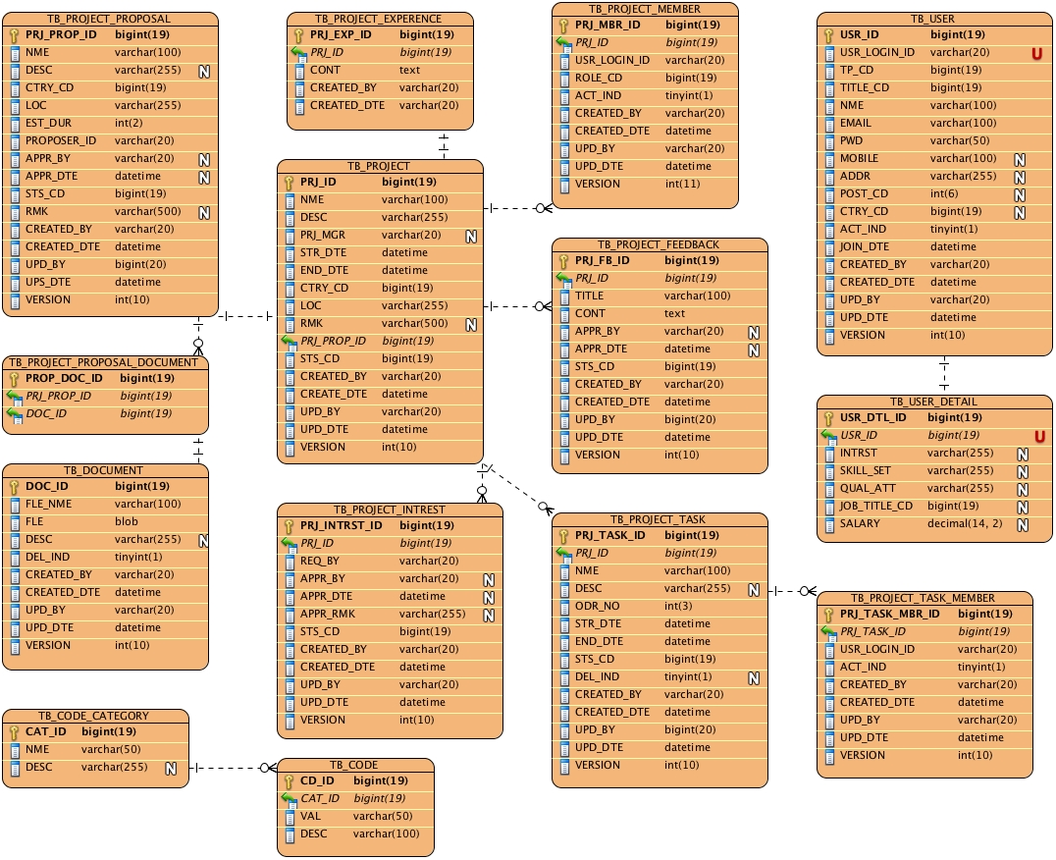

ANNEX D Amendment History

This is a record of all amendments made to the Document.
Version | Chapter / Section | Page No | Notes of Amendments or Changes
2. | 2.2 | 3 | - Amendments to the statement in poInt 1.

